BIO
MANOAH KEFA WILLIAM
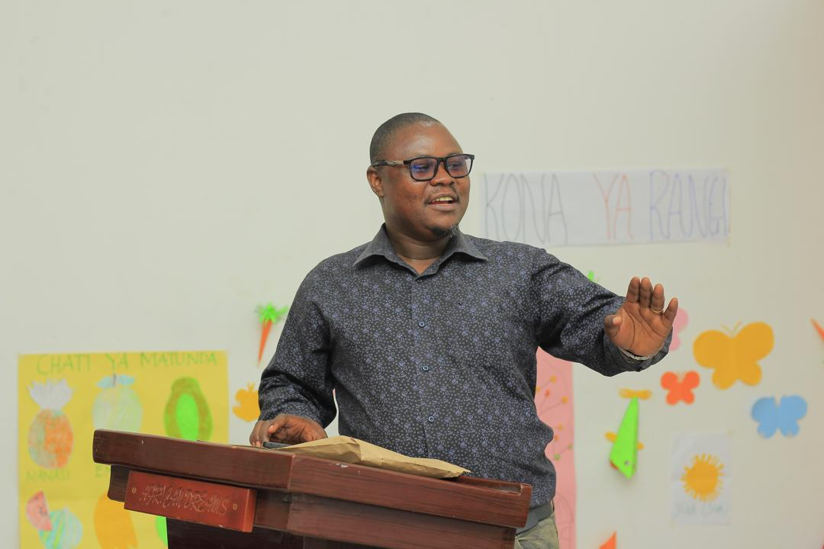
Manoah Kefa William is an experienced professional in the Early Childhood Development (ECD) sector, holding over 10 years of experience, including 8 years of direct involvement. Manoah has managed numerous ECD programs, notably leading three major projects in Tanzania from 2017 to 2021. These projects included establishing 30 satellite pre-primary classes, leading the construction and opening 35 ECD centers “play labs” in the government primary schools in Tanga, opening and leading 55 study centres for out of school girls “ALP Centers”, in collaboration with Institute of Adult Education (IAE), supporting and coordinating the establishment of ECD Radio programme MALEZI na BRAC (Parenting with BRAC) with Tanzania Broadcasting Cooperation (TBC). Additionally, Manoah has served as a Technical Advisor for Early Childhood Development in South Sudan
Currently, as a Senior Manager for the Education and Early Childhood Development Programme at BRAC International, overseeing ECD and Education programs across multiple countries where BRAC International operates. He is working with Country dreams in designing, fundraising and implementing programmes. Manoah has a strong track record of collaborating with governments to develop national ECD documents and protocols, ensuring comprehensive involvement and implementation. Significant contributions include developing the National Caseworkers Guide for Tanzania and leading the creation of the Sierra Leone ECD Teacher’s Guide for children aged 3-6.
Manoah has strong experience in youth and women programming, as he led various programmes that supported Youth Empowerment, and women access to Income Generating Activities (IGA). He was the Programme Manager for Community Rise Programme, an EU funded WE programme in Northern Bahr el Ghazal and Western Equatoria States of South Sudan.
In Tanzania, Manoah is an active member of the National ECD Taskforce and has contributed to creating the ECD Care Workers Guide. Manoah is also involved in reviewing ECD models in Tanzania, working with UNICEF, OPM, PORALG and Ministry of Community Development, Gender and Special Groups. Manoah possesses a profound understanding of Tanzania's government structure and technical frameworks for ECD service delivery, coordinating efforts across stakeholders. Manoah's experience ensures effective coordination and delivery of ECD services from national to community levels. A native Swahili speaker fluent in English, Manoah demonstrates strong writing, analytical, and communication skills, essential for managing complex ECD programs and initiatives.
Manoah has a Bachelor of Education and he is pursing Masters in Education Management and Administration at the University of Dar es Salaam.

